TAHOSSA NWZ MOCK EXAM AUGUST 2025
B/MATHEMATICS

MARKING SCHEME
- (a) Write a number in which O represents hundreds, 7 represents ten thousands, 3 represents ones, 9 represents thousands, 6 represents hundred thousand and 8 represents tens. Solution
Solution
    - hundreds
    - thousands

−

𝑡
𝑒
𝑛

    - ones
    - - thousand ➢  hundred thousands
    - ten
    - ………………………02 marks
  - Convert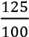 and 360% to decimal, then approximate their products to one significant figure.
Solution
    - ………………………0.5 mark
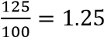
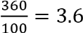
    - ………………………0.5 mark
    - 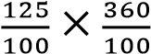
    - 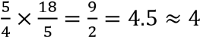………………………01 mark
  - 14 - 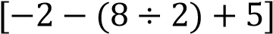 solution
    - 14 − [−2 − 4 + 5]
    - 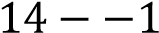
    - ………………………02 marks
- (a) If log 2 = 0.3010, Find the value of log 5 Solution
    - Given that 
    - 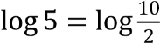 …………………………………. 01 marks
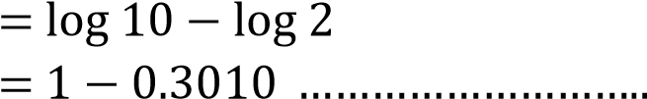
⇨
    - 0.5 marks
    - =0.6990 ……………… 0.5 marks
(b)If 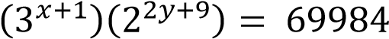 find the values of x and y.
Solution
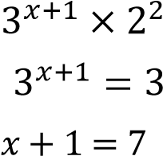
    - 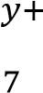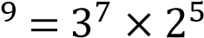
⇨
⇨
    - 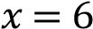 and ……………………………………………….01
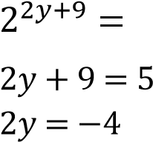
    - 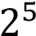
⇨
⇨
    - 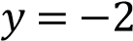 ……………………………………………………….01
    - 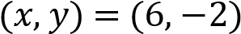

(c)Simplify by rationalizing the denominator of 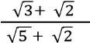 Solution
    - 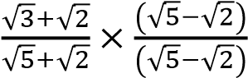……………………01
⇨ 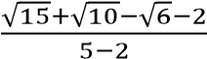
     
⇨ 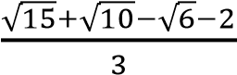  ………………………01
- (a) A bag contains 5 red and 4 blue balls. Two balls are drawn in succession without replacement. Find the probability that both are red.
Solution
⇨  Sample space = 5r+4b= 9
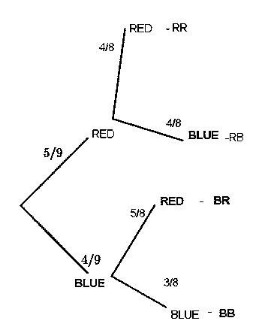 ………………01 mark Tree diagram

⇨………………………01 mark
⇨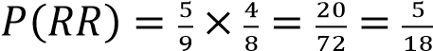…………01 mark
  - In a class of 35 students, 19 take physics, 18 take History and 3 take neither of the two subjects. Calculate how many students take i) Both subjects ii) Physics or History Solution
    - 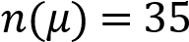
    - 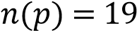
    - 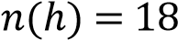⇨ 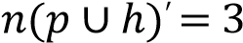
    - Venn diagram
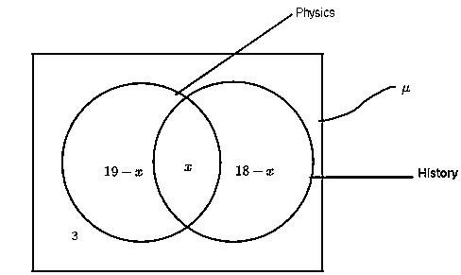
    - 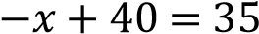
    - 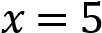
    - (i) Both is 5 students ………………………01 mark
    - (ii) Physics or history is 35-5 =30 students ………………………02 marks
- (a) Find the equation of a line passes through the point of intersection of the lines
3x -2y -8=0 and 2x+y=3 and is perpendicular to line 4x +3y=0 Solution
    - Solve the equation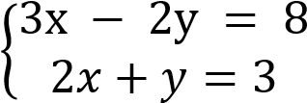
    - 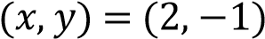
    - Now 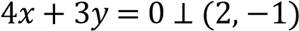 ⇨ 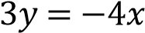
    - 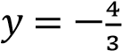
    - 1
⇨ 
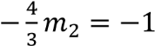
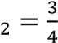
    - ………………………02 marks
𝑓
𝑜
𝑟

⊥=
𝑀
1
𝑀

2

−
=
𝑚
    - 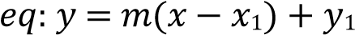
𝑦

=

(
𝑥

2) −
1
−
    - 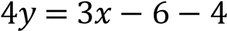
    - 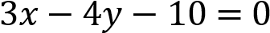………………………01mark
  - If a =3j – i and b=5i-2j and c = 4a + 3b find
(i).Magnitude of ç
(ii).Direction of ç Solution
(i) Magnitude 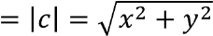 …………….0.5 mark
    - 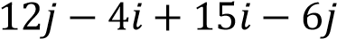
    - 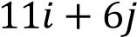………………………01mark
⇨ 
(ii) direction
    - 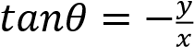…………………………….0.5 mark
    - 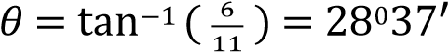………………………01 mark
- (a) Given that Area =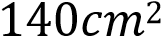

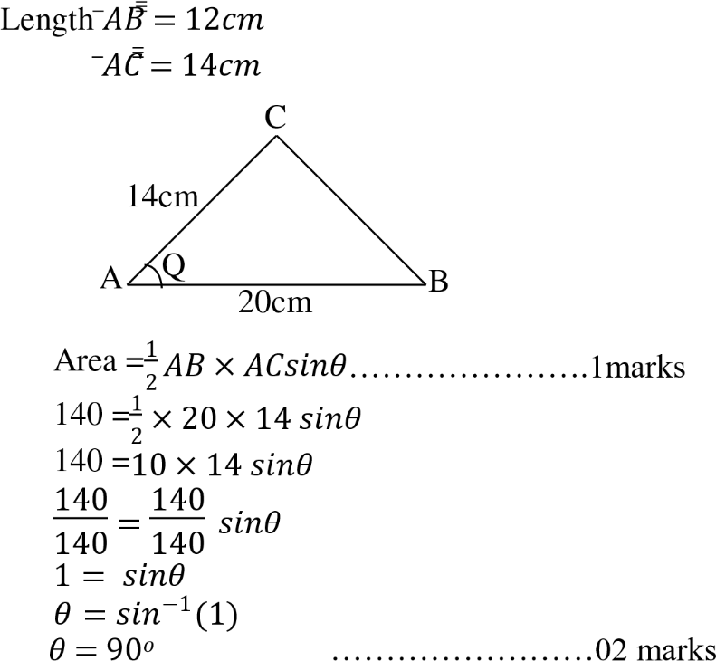

(b)(i)From the Rectangle JKLM given below (i) name two triangles which are congruent. (ii) Prove your answer in (i) above
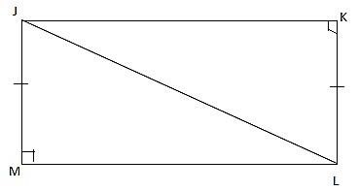
Solution
    - ………………………01 mark
    - ………………………01 mark
(ii) Angle  is equal to  by SSA………………………01 mark
- (a) Given that (Z + 1) is directly proportional to x and inversely proportional to the
square root of y. If x =2 when y=4 and Z =4 find Z when X = 3 and y =9 Solution
    - 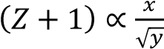
    - 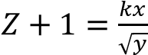
    - 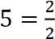
    -  Then
    - 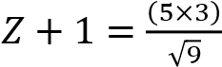 ……………01 mark
    - Z+1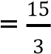
    - 
    - ………………………02 marks
  - A bus travels 240 km using 16 liters of diesel. How many liters of diesel are needed to
drive 90km?
Solution
    - 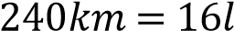⇨ 
    - 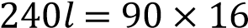
    - 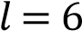
=6 litres………………………03 marks
7(a) On January 1st 2015 MTL group started a business with a capital in cash of 2,000,000/=
January 2. Purchased goods for cash 1,400,000/=
3. Sold good for cash 1,000,000/=
6. Purchased goods for cash 60,000/=
15. Paid rent for cash 220,000/=
26. Sold goods for cash 620,000/=
Prepare the cash account and balance it

Solution
MTL GROUP JANUARY 2015
Dr |  |  |  |  | Cr
Date | Particular | Folio | Amount | Date | Particular | Folio | Amount
1/1  3/1  26/1  01/02 | Capital  Sale  Sale  Balance | 01 03 06  d/c | 2,000,000/=  1,000,000/=  620,000/= | 2/1  4/1  15/1  31/1 | Goods  Goods  Rent  Balance | 02 04 05 b/c | 1,400,000/=  600,000/=  220,000/=  1400000/=
1/1  3/1  26/1  01/02 | Capital  Sale  Sale  Balance | 01 03 06  d/c | 3,620,000/= | 2/1  4/1  15/1  31/1 | Goods  Goods  Rent  Balance | 02 04 05 b/c | 3,620,000/=
1/1  3/1  26/1  01/02 | Capital  Sale  Sale  Balance | 01 03 06  d/c | 1,400,000/= | 2/1  4/1  15/1  31/1 | Goods  Goods  Rent  Balance | 02 04 05 b/c
ALL TABLE ………………………03 marks
b) If the ratio of sacks of maize, millet and cassava in certain store is 6:7:3. There are 42
sacks of millet. Find the total sacks in a store.
Solution
      - Total ratio 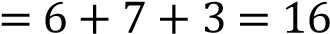……………..01 mark
      - Total store
      - For maize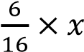…………………………..01mark
      - 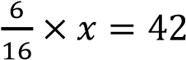
      - 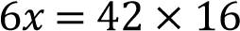
      - 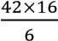
      - Total sacks is 112………………………01 mark
8(a) If the common difference of an A.P is -2 and the third term is 0. Find
(i) The first term
(ii)The general term Solution
(i) 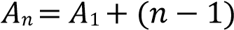
      - 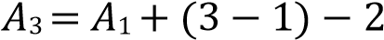
      - 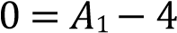
      - 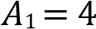
      - First term is 4………………………1.5 marks
(ii) General term
      - 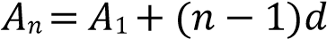
      - 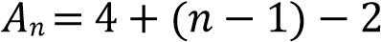
      - 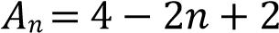
      - 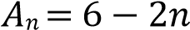………………………1.5 marks
(b) A certain geometric progression has a common ratio of 2 and the sum of the first ten terms is 155. Find the first term and give the formula for the nth term Solution
      - 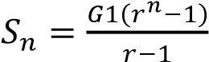
      - 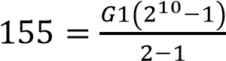
      - 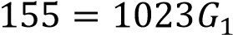
      - 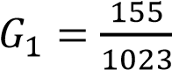………………………1.5 marks
      - First term is 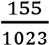
      - The 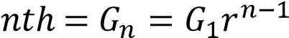
      - 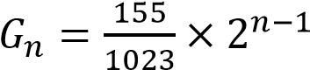………………………1.5 marks

9(a) Without using tables, find the value of 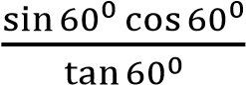 and simplify your answer.

Solution
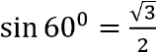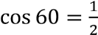
⇨ 

⇨ 

⇨ 
𝑡𝑎𝑛
°
60
=
√
3
 

⇨

sin
60
0
cos
60
0
tan
60
0
=
√
3
2
×
1
2
√
3

………………………….02 marks

      - 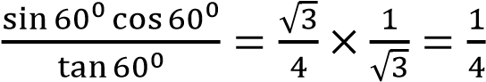 ………………01 mark
(b)The sides of a right angle are 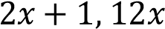 and . Find the value of in cm if the hypotenuse is 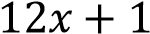
Solution
 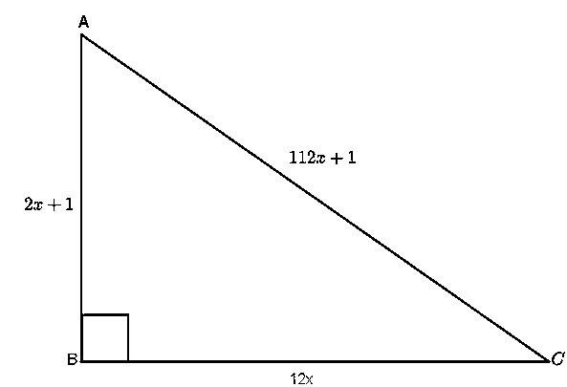
      - ………………………01 mark
      - …………………………01 mark
      - 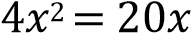
      - 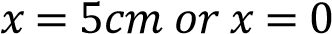………………………01 mark
10(a) Use factorization method to find the value of X if 8x² – 34x + 21 = 0 Solution
      - Sum 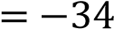
      - Product 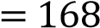
      - Numbers = (−24, −7)………………..01 mark ⇨ …………01 mark
      - 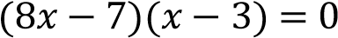
      - ………………………01 mark
𝑥

=

𝑜
𝑟

𝑥

3
=
(b) The average of two numbers is 7 and three times the difference between them is 18.
Find the two numbers Solution
    - 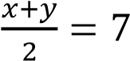………………01 mark
    - 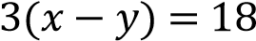
    - 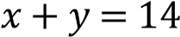…………………01 mark
    - 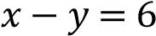
    - Solve simultaneous equation
    - 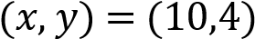
The numbers are 4 and 10………………………01 mark

SECTION B (40 MARKS)
11(a)These scores of Mathematics Examination done by 60 students were recover as follow
36,26,52,54,51,34,26,29,34,26,30,56,21,49,35,5822,38,28,26,41,53,31,
32,20,21,61,58,36,50,56,63
27,30,63,30,60,34,48,28,41,57,24,35,35,33,20,59
36,25,32,43,56,30,50,42,21,33,45,25
i) Prepare frequency distribution table using intervals 20- 24,25 -29, 30-34 ii) Calculate mode and Median
⇨ Solution ………………………03 marks
Class interval | Class mark | Frequency | Tally | C. F
20-24  25-29  30-34  35-39  40-44  45-49  50-54  55-59  60-64 | 22  27  32  37  42  47  52  57  62 | 8  10  12  7  4  3  6  7  4 | ////////  /////////  ////////////  ///////  ////  ///  //////  ///////  // | 8  18  30  37  41  44  50  57  60

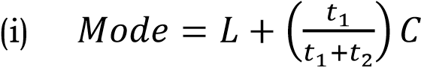
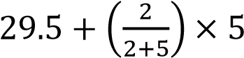
⇨ ………………………1.5 marks

29.5 +

30.9
=

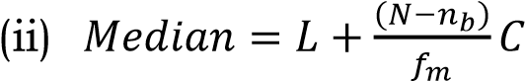

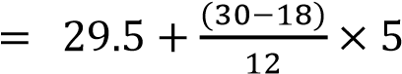
⇨ =………………………1.5 marks
29.5 +

=
33.5

(b) solution

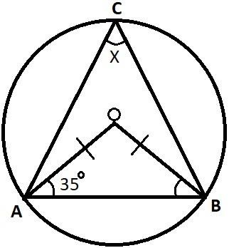
OA=OB= r (radii)
 (Base angle of an isosceles)………………01mark
Thus 

But
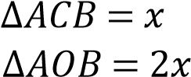
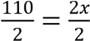
x = 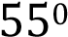

Therefore the value of 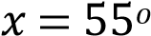 ……………… 01 mark
12 (a) The figure below shows a rectangular prism in which AB= 10CM, BC= 8cm and GC =
6cm
(i).Calculate the length AG (Two decimal places)
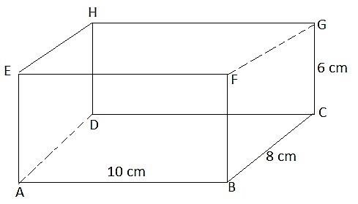
(ii).The angle that AG makes with the plane ABCD
Solution
AG is under 
But  is the diagonal of 
Use ………………………..01 mark
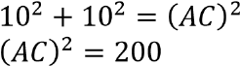
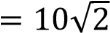
………………………………………………….01 mark

𝐴
𝐶

Now use

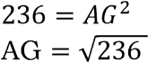
cm ………………………01 mark
(ii) Angle AG
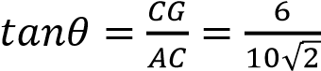……………………………….01 mark

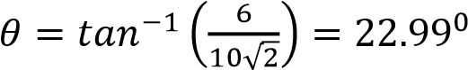………………………01 mark
(b) A and B are two points on latitude 70°N. Their longitudes are 62°W and 118°E respectively. Calculate the distance in Kilometers from A to B if the Earth’s diameter is 12,800km along a parallel of latitude Solution
Formula 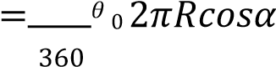…………………………………..01 mark
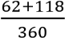 ………………….02 marks

× 2 × 3.14 × 6400 × cos70
0
6873.3km ………………………02 marks
13(a) I think two numbers. If I double the first and add the second I get 18. If I double the first and subtract the second I get 14. Use matrix method to find the two numbers
Solution
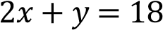
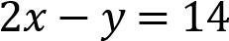
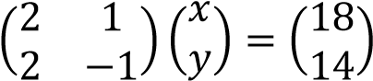…………………………..01 mark
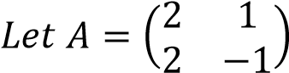
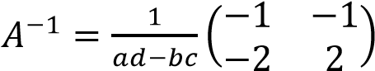
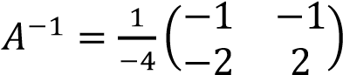
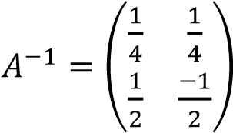……………………………………….01 mark
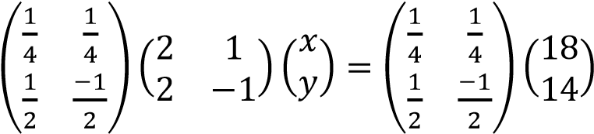………………………..01 mark
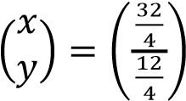
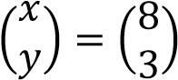
numbers are 8 and 3 ………………………01 mark

- Given 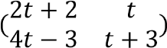 is singular

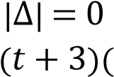
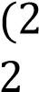
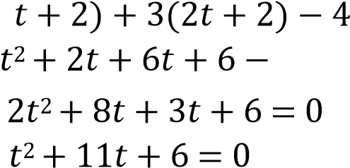
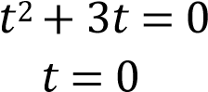
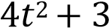
………………01
-2
………………………………01
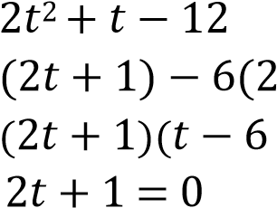
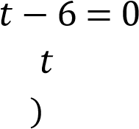
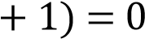

or t-6=0
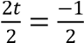 or t=6 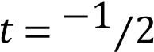 or t=6
Therefore t=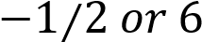 ……………….. 01 mark
- Find the image equation of the line 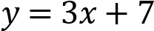 after reflection in the line 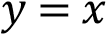 Solution
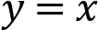, its matrix is 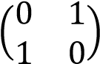…………………….01 mark
And y=3x+7 use x=0 , y=7 and x=1 ,y=10
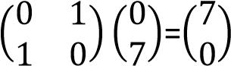
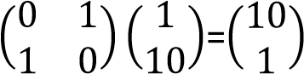
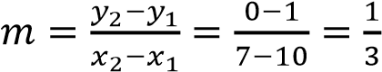 …………………………01 mark
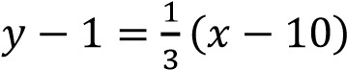
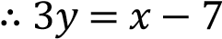………………………01mark
14(a) Maximize 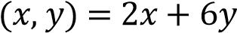 subject to the following constraints
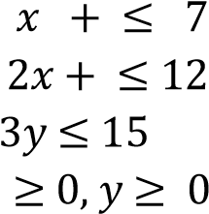
Graph
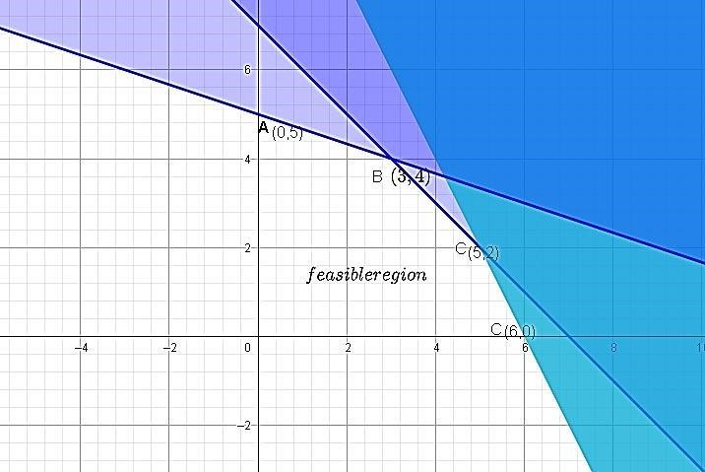
…………03
Table result
Corner point | 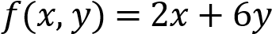 | Total value
A(0,5)  B(3,4) C(5,2)  D(6,0) |  | 30  30  22  12
The maximum is 30 ………………………02
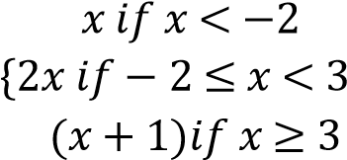
(b) The function f(x) defined as:- f(x) =

- Sketch the graph of f(x)
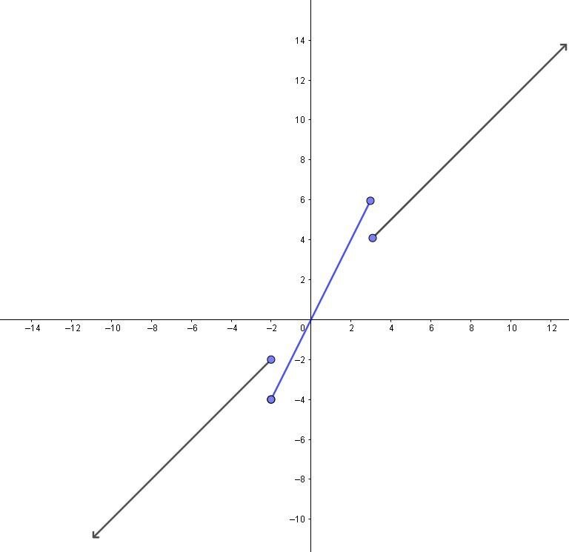graph……………03marks
- State domain and range of f(x)
Domain ………………………01
Range 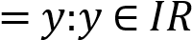………………………01

